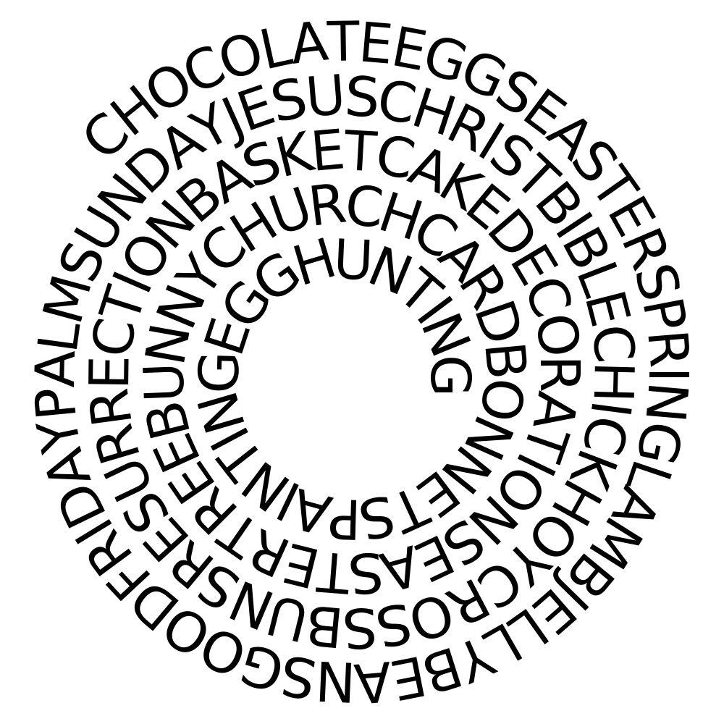
FIND THE WORDS
POEM :EASTER BUNNY
THE EASTER BUNNY CAME BY TODAY
AND LEFT SURPRISES ALONG HIS WAY.
COLORFUL EGGS ARE ALL AROUND
WITH BASKETS IN HAND WE SEARCH THE GROUND.
HIDIND IN PLACES HERE AND THERE
EASTER EGGS ARE EVERYWHERE .

1. CHOCOLATE RABBIT 2. EASTER BONNETS 3. EASTER SUNDAY AND GREETINGS 4. GOOD FRIDAY 5. JELLY BEANS 6. PALM SUNDAY 7. TULIPS 8. TREE IN SPRING 9. SPRING 10. ROAST LAMB 11. RESURRECTION 12. NEST 13. CARD 14. LAMB 15. JESUS CHRIST 16. HOT CROSS BUNS 17. HOLY WEEK 18. HOLY BIBLE 19. EASTER CHICK 20. EGG PAINTING 21. EGG HUNTING 22. EASTER EGG TREE 23. BASKET 24. EASTER EGGS 25. EASTER CUPCAKES 26. EASTER CAKE 27. EASTER BUNNY 28. DECORATIONS 29. DAFFODILS 30. CROSS 31. CHURCH 32. CHOCOLATE EGG

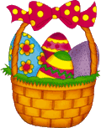 |  | 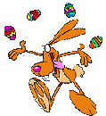 | 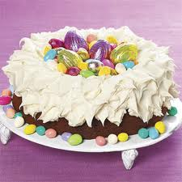
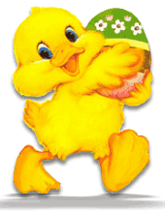 |  | 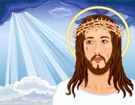 | 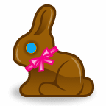
 | 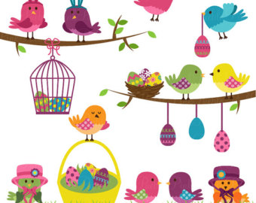 | 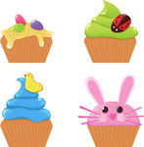 | 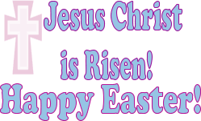
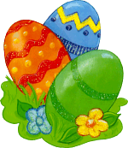 | 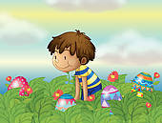 | 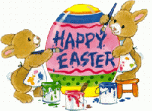 | 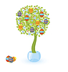
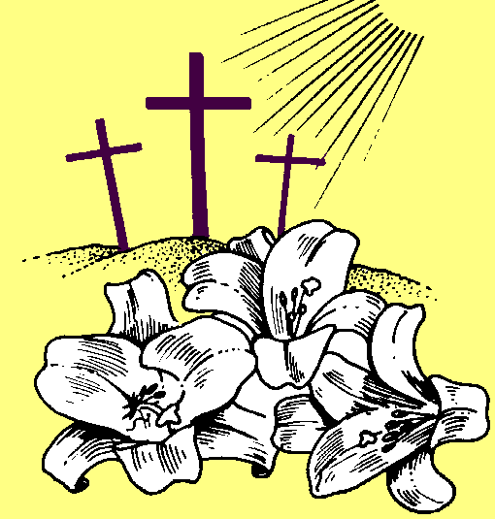 | 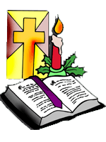 | 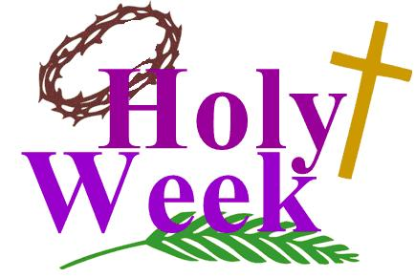 | 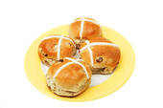
 | 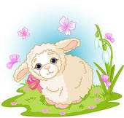 | 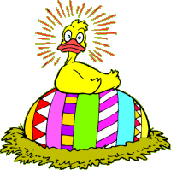 | 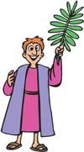
 | 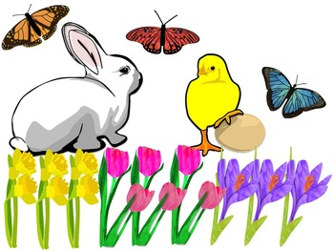 | 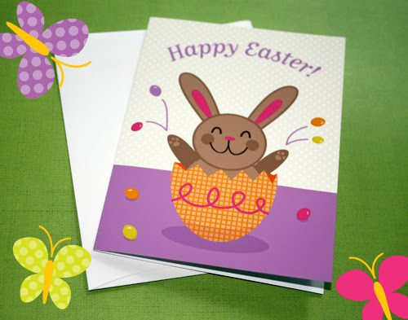 | 